AI Customer IT Support Ticket Classification

ECE569A

July 27, 2026

Tan Dai Ngo (V01073190), Yuanming Wang (V01028720), Da Zhang (V01062902), Yafei Fan (V01087635)

Table of Contents

Abstract/Executive Summary
1. Introduction
Background
Motivation
2. Related Work
3. Problem Formulation
4. Methodology and Evaluation
5. Results and Discussions
6. Conclusion
7. Future Work
References

Abstract
Customer support teams often receive large numbers of tickets that must be classified, prioritized, and routed before an issue can be addressed. This project investigates whether artificial intelligence methods can support this triage process by predicting ticket type, priority, and destination queue from ticket text. We compared a TF-IDF Logistic Regression baseline with TF-IDF Linear and RBF kernel SVMs, a TF-IDF k-nearest neighbours model using cosine similarity, and a neural network trained on fixed DistilBERT embeddings. Hyperparameters were tuned through stratified cross-validation using randomized search for the SVM models and a Genetic Algorithm for the neural network.

1. Introduction
Customer support systems are widely used in many industries, such as e-commerce, software services, banking, and IT help desks. Every day, support teams receive a large number of tickets from users who report technical problems, service requests, account issues, or billing questions. In practice, these tickets need to be reviewed and assigned to the correct category, urgency level, and support team before they can be handled efficiently. This process is usually called ticket triage.

Traditionally, ticket triage is done by human agents. However, when the number of incoming tickets becomes large, manual triage can be slow, expensive, and sometimes inconsistent. Different agents may make different decisions for similar tickets, especially when the ticket text is long or unclear. Because of this, many organizations are interested in using artificial intelligence methods to assist or automate ticket classification and routing.

The motivation of this project is to explore whether AI methods can improve the efficiency and consistency of ticket triage. In our project, we focus on three practical prediction tasks: ticket type prediction, priority prediction, and queue prediction. These three tasks are important because they directly affect how quickly a ticket is handled and which team will be responsible for solving it.

This problem is also interesting from a machine learning perspective. Support tickets often contain unstructured text, and different classes may use similar words and expressions. For example, some technical issues may look similar to product issues, and low-priority tickets may sometimes use language that sounds urgent. Because of these challenges, ticket triage provides a meaningful application for comparing different AI approaches, including classical text classification, retrieval-based methods, and neural models.

In this project, we use an English customer support ticket dataset and evaluate multiple AI methods on the three triage tasks. Our goal is not only to measure prediction accuracy, but also to understand which methods are more suitable for this problem and what kinds of errors are still difficult to avoid.

2. Related Work

A relevant existing implementation for this problem can be found on the Kaggle notebook Queue & Priority Prediction + Sentiment Analysis by Sukanto [12], which applies traditional machine-learning methods to customer IT support ticket classification using the same provided dataset [1]. The notebook uses the customer's IT Support Ticket Dataset [1] and explores queue prediction, priority prediction, and sentiment analysis using text-based features and classification classifiers. This work is useful as an external reference because it demonstrates that ticket text can be transformed into numerical features and used for supervised classification tasks such as routing tickets to queues and predicting their priority level.

Although the Kaggle implementation achieved a relatively high performance in terms of prediction accuracy, it has several methodological limitations that restrict the strength of its reported result, making it not trustworthy.

The dataset used in the notebook contains only 399 records, which produces a very small test set, and it does not use stratified splitting when separating the training and test data. The implementation is relatively simple, containing only a small number of queue categories compared with our methodology. It also relies mainly on accuracy as the primary evaluation metric and does not consider the class imbalance.

Overall, the Kaggle notebook is valuable as related work because it shows an initial application of machine learning to the prediction of customer support tickets. However, its small dataset, limited validation design, simple class structure, and reliance on accuracy make it more appropriate as a preliminary baseline than as a robust performance benchmark. Our work extends this by using a larger dataset, a more challenging classification setup, stratified evaluation, richer performance metrics, and systematic model selection.

3. Problem Formulation

Classification Formulation: Predictive Classifiers

- State: A current modelling configuration consisting of a TF-IDF or BERT text-embedded representation, a classifier, and hyperparameter values.
- Initial State: A labelled dataset of support tickets containing combined_text and known labels such as type, priority and queue.
- Successor function: The input sequence undergoes a step-by-step mathematical transformation mapping to a transition from raw text to a definitive category assignment:
  - Feature Extraction / Embedding: The text is converted into a structured numerical format. This is achieved either via statistical term-frequency techniques, TF-IDF, or deep learning contextual representation,pre-trained BERT transformer encoder.
  - Model inference: The processed feature array by TF-IDF or tensor by BERT is passed through the optimally trained model configuration to calculate target decision boundaries or output class probabilities.
- Goal Test: Test whether the transformation pipeline successfully predicts and maps the input vector to an output label belonging to a predefined target label.
- Cost Function: The performance cost to be minimized over the entire unseen test set partition is defined by classification error, which is measured using standard evaluation metrics like test accuracy or F1-scores.

AI Search Formulation: Hyperparameter Optimization

- State: A specific configuration vector representing a unique assignment of values to all tunable hyperparameters within a defined search space $H$:
- For K-NN architecture: The state scaler vector involves parameter $k$, the number of neighbours chosen, and the distance matrix that defines the “similarity” between data points.
- For SVM architectures, the state vector includes parameters like regularization penalty ($C$), kernel coefficient ($gamma$), or class weighting strategies
- For Neural Networks: The state vector expands to include parameters such as learning rate, batch size, number of hidden neurons, number of hidden layers, dropout rate, and cost optimization algorithms.
- Initial State: A randomly generated combination of hyperparameters; zero search iterations completed.
- Successor Function: Generate a new hyperparameter configuration state from the search space $H$ based on the chosen selection strategy.
  - Grid Search: Systematically selects the next adjacent node in a predetermined grid mesh.
  - Random Search: Randomly samples the next state-space coordinates from predefined continuous or discrete probability distributions.
  - Genetic Algorithm: Evaluates the fitness (validation performance) of the current population of states, then applies evolutionary operators, selection, crossover and mutation to generate successor states.
- Goal Test: Tests whether a target cross-validation score that maximizes a given validation metric (accuracy or F1-score) is reached or if a termination condition is satisfied, which is defined by reaching a budget constraint (executing a fixed number of search iterations).
- Cost Function: Formulated as an error-minimization objective for machine learning algorithms, the cost function at a given state is defined as the validation loss or the inverse of the target optimization metric (1- validation F1-score).

4. Methodology and Evaluation

Methodology

In this project, we treat ticket classification as three separate supervised learning tasks: predicting ticket type, priority, and queue from the ticket description. Three pipelines are built for each task, so that we can compare a traditional TF-IDF approach, a retrieval-based kNN method, and contextual embeddings from DistilBERT. The dataset [1], target labels, train/test split, and random seed stay the same across all pipelines, and thus any performance difference comes from the modelling approach itself and not from the setup. Text representation, classifier, and tuning method are the only things that actually differ.

TF-IDF [8] is the basis for the first pipeline, turning each ticket description into a sparse numerical vector. We include both unigrams and bigrams, so that the model picks up short phrases as well as single words, and cap the vocabulary at 15,000 features with min_df = 2 to cut out extremely rare terms. Afterwards, these vectors are used to train two SVM [6] classifiers: a Linear SVM, which builds a linear boundary directly in the TF-IDF space, and an RBF kernel SVM, which maps the vectors into a higher-dimensional space and can capture non-linear relationships. Comparing the two techniques lets us see whether a linear model is enough or whether a non-linear boundary actually helps. Both SVM variants get tuned with RandomizedSearchCV [10] under 3-fold stratified cross-validation [9] instead of manually chosen values. For the Linear SVM, the search optimizes a C value and the class weight setting, but for the RBF SVM, the search tunes an additional gamma value. Thirty sampled configurations are evaluated for each method to select the one with the highest scores on average as the optimal model, retrained on the full training set.

A second TF-IDF-based pipeline is built using retrieval and k-nearest neighbours [7]. In this setting, each ticket is again represented by its TF-IDF vector, but instead of learning a global decision boundary, the model predicts the label of a new ticket by searching for the most similar historical tickets in the training set. Cosine similarity is used as the similarity measure because it is well-suited for sparse text vectors, as it compares the direction of two vectors rather than their magnitude. This allows tickets with similar word patterns to be considered close even when their text lengths are different. Brute-force neighbour search is applied to compare each test ticket against all training tickets. Then we use distance-weighted voting so that closer neighbours contribute more strongly to the final prediction. Different values of k are tested in order to study how the neighbourhood size affects performance, since a smaller k relies more strongly on the closest matching case, while a larger k produces a more stable but less specific vote. This retrieval-based pipeline is included because customer support tickets often contain recurring issue patterns, making case-based reasoning a meaningful alternative to purely parametric classification.

Pretrained DistilBERT [3] embeddings power the third pipeline instead of TF-IDF. Each ticket description is tokenized and passed through the pretrained encoder [4], and the resulting token embeddings are mean-pooled using the attention mask into a single 768-dimensional vector per ticket. Before training, these embeddings go through StandardScaler so that every feature has zero mean and unit variance, which gives more stable convergence. The MLP [2] handles the actual classification. Since testing every combination of architecture and optimization settings wasn't practical, we used a Genetic Algorithm [5] to optimize the MLP hyperparameters. Each candidate represents one MLP configuration, including its hidden layer sizes, activation function, learning rate, and alpha. Starting from a random population, we score each individual using its mean 3-fold stratified cross-validation score, and the tournament selection (k = 3) picks parents based on that fitness. Uniform crossover combines the parents' hyperparameters into an offspring, with mutation (rate 0.3) adding variation on top of that. We keep the best-performing individual from each generation unchanged, so that it is preserved in the next generation. The entire process runs for several generations.

The two tuned pipelines are given a comparable computational budget for model selection, so that the comparison stays fair: 30 candidate configurations for each SVM search, and 40 for the Genetic Algorithm, spread across 8 individuals over 5 generations. Each full pipeline is wrapped in a single Pipeline object as well, so that the TF-IDF fitting and feature standardization only ever happen on the training stage during cross-validation. Following this process, nothing from the validation data or the test data leaks into the training phase. For the retrieval-based kNN pipeline, no hyperparameter search procedure is used beyond testing different k values, since the main purpose is to evaluate retrieval quality under the same train/test split rather than to build a heavily tuned classifier.

Evaluation

The dataset gets split once per task into an 80/20 ratio based on a stratified train/test split [9] with a fixed random seed, keeping the class distribution consistent across both partitions. The test set is set aside for final evaluation only and never touched during tuning or model selection. Tuning itself happens entirely on the training partition, using 3-fold stratified cross-validation [9] for both the SVM and MLP pipelines. Once the best hyperparameters are found, the selected model gets retrained on the full training set and runs against the test set exactly once. For the retrieval-based kNN pipeline, the same train/test split is used, but no cross-validation-based hyperparameter tuning is performed beyond testing different values of k on the same training/testing setup.

The evaluated metric varies based on the relevant task. Weighted F1-score [11] works for ticket type prediction, since the dataset has a dominant class there. Priority and queue prediction use macro F1-score instead, since those tasks are more balanced but also harder to accomplish, and macro F1 keeps the minority classes from getting buried during tuning or evaluation. The same metric applies during both tuning and testing, so that the two segments of the pipeline line up. Also, we generate a full classification report and a confusion matrix [11] for every trained model to give us class-level detail on where a model actually succeeds or fails, not just one number at the end.

Experimental Validation

Ten independently optimized models come out of this in total: six from the TF-IDF pipeline (Linear and RBF SVM for each of the three tasks), one from the retrieval-based pipeline (one KNN-based model with multiple k values compared), and three from the DistilBERT pipeline (a GA-optimized MLP per task). Each SVM search runs 30 configurations under 3-fold cross-validation, which comes to 90 model fits per search. Each GA run works out to 120 model evaluations under that same cross-validation scheme.

The SVM search space wasn't fixed from the start. Sampling ranges for C and gamma were first set while working on the ticket type task. Those ranges turned out to be too narrow once we moved to priority and queue, so we widened them for those two tasks specifically after seeing the initial results weren't enough. Dataset split, random seed, evaluation metrics, and cross-validation procedures all stayed fixed across every experiment, so that any performance differences we identify can be traced back to the models themselves rather than the setup around them.

5. Results and Discussions
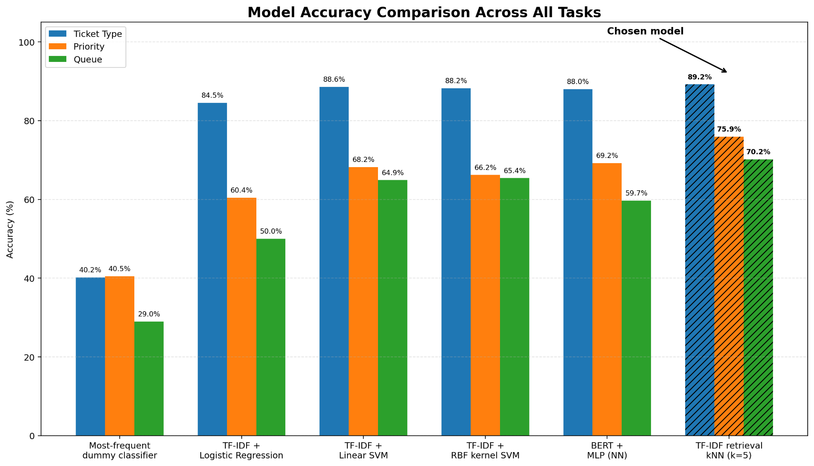
Figure 1: Visualization of the model comparison using histograms

Model | Ticket Type | Priority | Queue
“Most-frequent” dummy classifier | 40.2% | 40.5% | 29.0%
TF-IDF + Logistic Regression | 84.5% | 60.4% | 50.0%
TF-IDF + Linear SVM | 88.6% | 68.2% | 64.9%
TF-IDF + RBF kernel SVM | 88.2% | 66.2% | 65.4%
BERT + MLP (NN) | 88.0% | 69.2% | 59.7%
TF-IDF retrieval kNN (k=5) | 89.2% | 75.9% | 70.2%
Table 1. Test accuracy of the evaluated models
The results first confirm that the models learned meaningful patterns from the ticket text. The “most-frequent” classifier is a simple baseline that always predicts the most common class in the training data, regardless of the ticket content. Since even the Logistic Regression baseline clearly outperformed this classifier for all three tasks, the improvement shows that the model was learning useful relationships between the text and the target labels rather than only relying on class frequency. However, the size of the improvement varied by task. Ticket type was the easiest target, while priority and queue prediction were considerably more difficult.

5.1 Ticket Type Prediction
All four main approaches performed relatively well for ticket type. The classification reports show that Change and Request tickets were recognized almost perfectly by the SVM and neural network models. These ticket types often contain clear phrases such as requests to modify, replace, update, or provide something. The main remaining confusion was between Incident and Problem. These two classes can describe similar technical situations, but differ in whether the ticket represents a specific interruption or a broader underlying issue. That distinction is not always stated directly in the text.

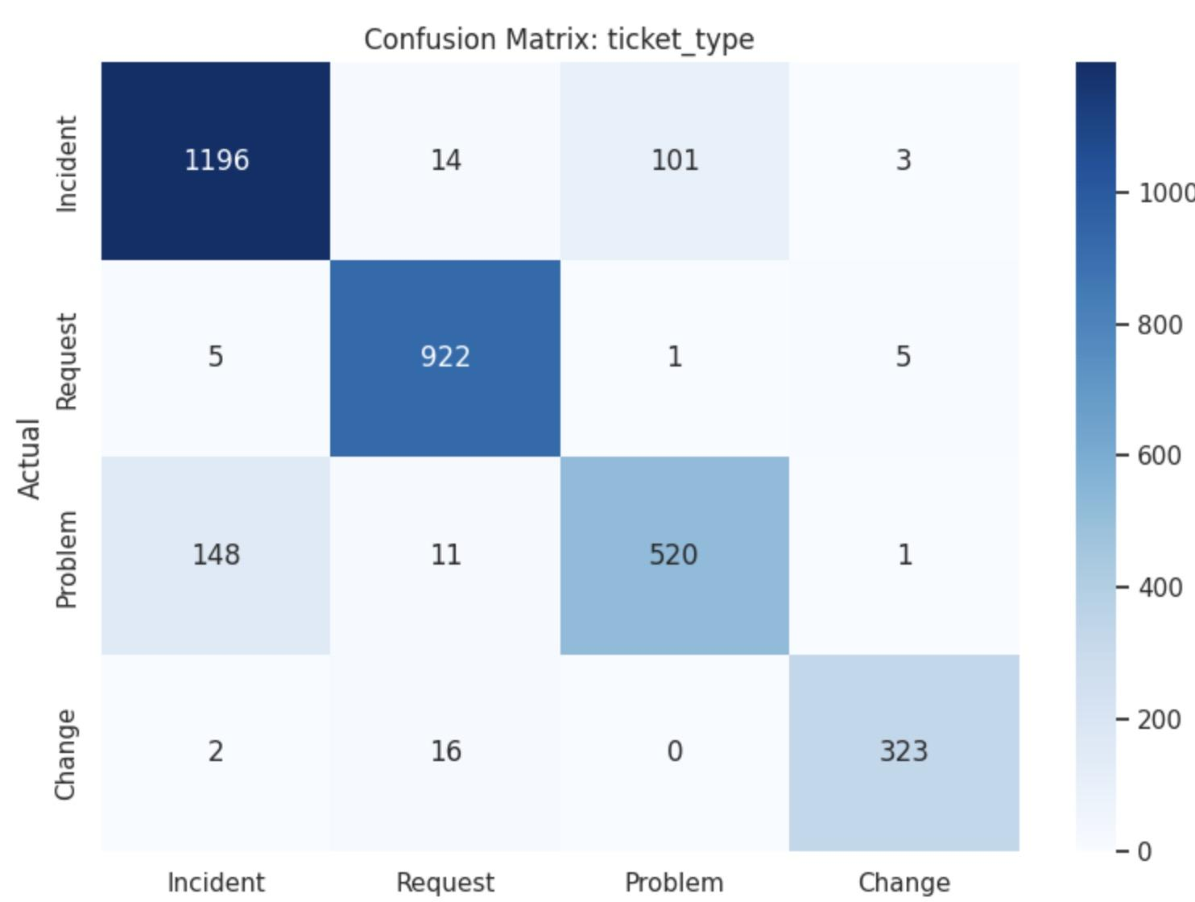
Figure 1. Confusion matrix for ticket type prediction (TF-IDF Retrieval + kNN, k = 3)

The small difference between the Linear and RBF kernel SVM also suggests that ticket types can be separated effectively using a linear decision boundary in the TF-IDF space. Applying a nonlinear kernel increased computational cost but did not improve the result for this task, since the TF-IDF original feature space is already well-separated by a linear classifier.

5.2 Priority Prediction
Priority prediction was more difficult because urgency is not always expressed through obvious keywords. Across the models, the low-priority class was generally the most difficult to identify. For example, the BERT model obtained an F1-score of 0.60 for low-priority tickets, compared with 0.74 for high-priority tickets. Some low-priority requests still contain words such as “issue,” “difficulty,” or “need,” which can make them appear more urgent than they are. At the same time, some genuinely urgent tickets describe their problem in neutral or formal language.

The BERT representation improved on Logistic Regression, showing that contextual information was useful for estimating urgency. However, it did not outperform retrieval kNN. One possible explanation is that the DistilBERT encoder was used only to generate fixed mean-pooled embeddings. It was not fine-tuned directly on the priority labels. The Genetic Algorithm optimized the MLP architecture and training parameters, but it could not adapt the underlying language representation to this specific dataset.

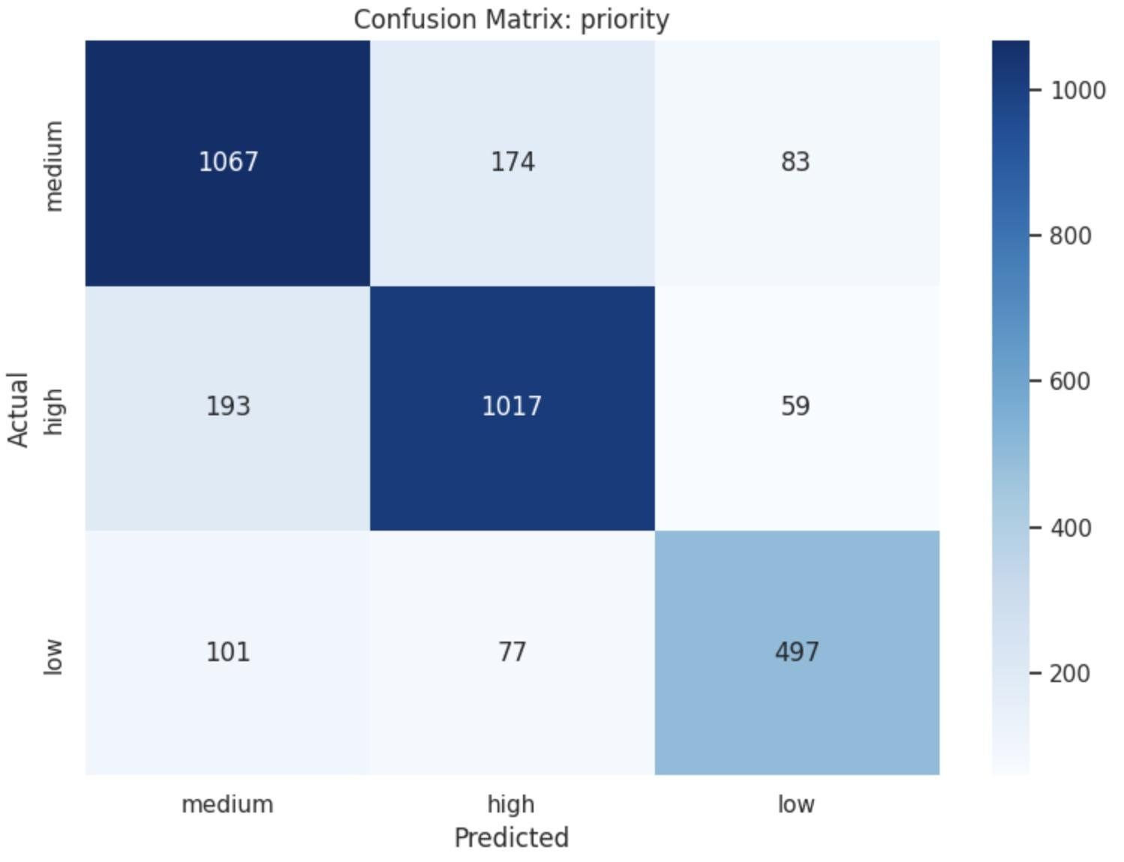
Figure 2. Confusion matrix for priority prediction (TF-IDF Retrieval + kNN, k = 3)

5.3 Queue Prediction
Queue prediction was the most fine-grained task because it contained ten possible classes. The RBF SVM and kNN models showed different strengths. The kNN model produced higher overall accuracy, while the RBF SVM achieved a macro F1-score of about 0.69 and performed particularly well on several smaller classes. For example, its F1-scores were approximately 0.73 for General Inquiry, 0.74 for Human Resources, and 0.80 for Service Outages and Maintenance.

The confusion matrices show that Billing and Payments and Service Outages and Maintenance were comparatively easy to identify because they contain more distinctive vocabulary. In contrast, Customer Service, IT Support, Product Support, and Technical Support were frequently confused. These queues share many terms related to software, devices, accounts, troubleshooting, and customer assistance. Their operational boundaries may also depend on information that is not present in the ticket text. For instance, several queues also handle semantically similar issues, such as IT Support, Technical Support, and Product Support, so their ticket text may overlap significantly. This confirms the challenge identified during the progress stage, where Technical Support contained 4,737 examples while General Inquiry contained only 236.
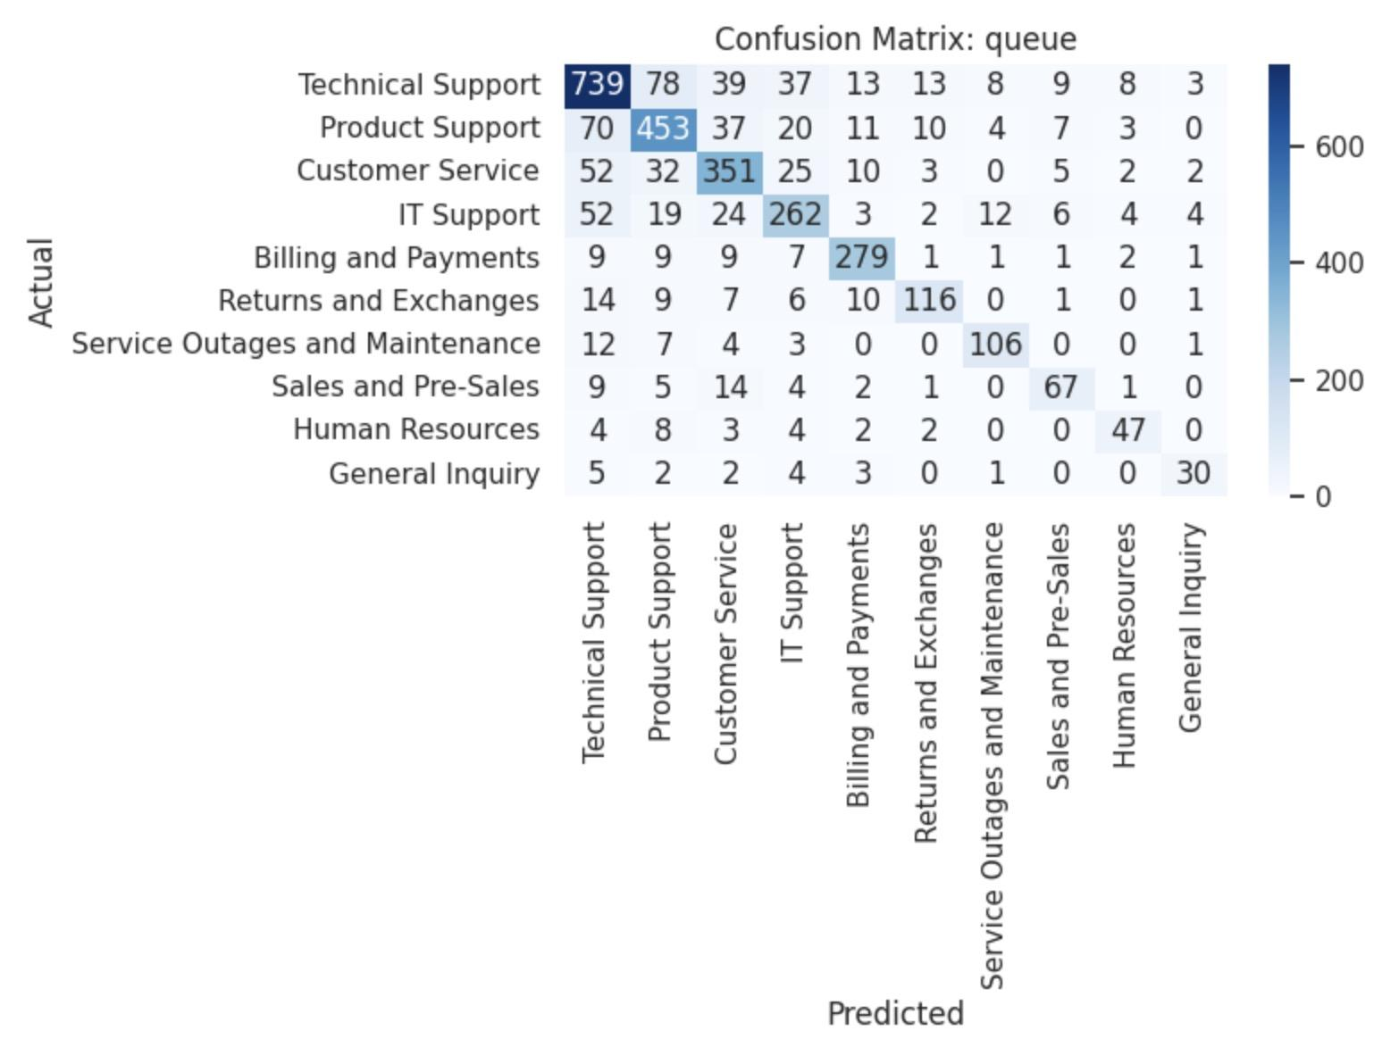
Figure 3. Confusion matrix for queue prediction (TF-IDF Retrieval + kNN, k = 3)

5.4 Comparison of the Modelling Approaches
The TF-IDF SVM results demonstrate that classical sparse-text models remain highly competitive. The Linear SVM was the best SVM for ticket type and priority, while the RBF SVM was slightly better for queue accuracy and performed well on minority queues. Therefore, a nonlinear boundary was useful for some fine-grained queue distinctions, but it did not provide a consistent advantage across all tasks.

The BERT neural network pipeline improved over Logistic Regression for every target, but it was not the strongest model overall. This shows that a more complex model does not automatically produce better results. The fixed BERT embeddings capture general semantic meaning, but they may also place semantically related support categories close together. This can make it difficult for the MLP to distinguish categories such as Product Support and Technical Support.

The strong retrieval result is consistent with the repetitive structure of the dataset. The retrieved-neighbour examples contain tickets with very similar phrases and issue descriptions. Instead of learning one global boundary, kNN can directly reuse the labels of closely related historical tickets. This appears especially useful when tickets describe recurring issues using similar templates.

The neighbourhood-size experiment also showed that performance decreased as k increased. In the exploratory sensitivity analysis, k=1 and k=2 both reached 91.0% type accuracy, 82.2% priority accuracy, and 77.8% queue accuracy. Larger neighbourhoods introduced less relevant tickets into the vote and gradually reduced performance, but they also introduced the ability to prevent overfitting, hence bringing better generalization ability. The model traded off 2% prediction accuracy in return for a significantly better generalization ability. Therefore, the k=5 results are retained as the main comparison, while the higher k=1 and k=2 scores should be treated as exploratory rather than unbiased final estimates.

Overall, the experiments show that the dataset structure strongly affects which model works best. Retrieval kNN was the strongest overall approach, SVM provided a reliable balance between performance and training cost, and the NN model demonstrated the value of contextual representations but required greater computational effort. Class imbalance, overlapping queue responsibilities, and ambiguous urgency remained the main sources of error. We addressed these challenges through stratified splitting, macro F1-based tuning, balanced SVM class weights, confusion-matrix analysis, and systematic hyperparameter optimization.

6. Conclusion
This project developed and compared several ML approaches for automatically classifying customer support tickets by type, priority, and destination queue. The evaluated approaches included a TF-IDF Logistic Regression baseline, TF-IDF Linear and RBF SVM classifiers, a cosine-similarity TF-IDF kNN model, and a BERT neural network.

The results show that automated ticket triage is feasible, although the difficulty depends strongly on the target. Ticket type could be predicted reliably, with the main models achieving approximately 88–89% accuracy. Priority prediction was harder because urgency was often implied rather than directly stated. Queue prediction was the most challenging because the ten support queues were imbalanced and several had overlapping responsibilities and vocabulary.

Among the main experiments, retrieval kNN with k=5 achieved the highest accuracy for all three tasks: 89.2% for ticket type, 75.9% for priority, and 70.2% for queue. The SVM models also performed strongly, and the BERT and neural network models improved over the Logistic Regression baseline but did not consistently outperform the simpler models.

An important conclusion is that greater model complexity does not necessarily lead to better performance. In this dataset, local similarity between recurring tickets was more useful than a general contextual embedding for several tasks. At the same time, none of the models completely resolved the confusion between related support queues or the ambiguity of ticket priority. Under the current limitations, such as limited training examples, the proposed system would therefore be most appropriate as a decision-support tool that recommends labels to human agents rather than making every routing decision without review.

7. Future Work
Further work should address class imbalance and the structure of the queue labels. Cost-sensitive loss functions, oversampling (SMOTE), focal loss, or additional examples from minority classes could improve General Inquiry, Human Resources, and other smaller queues. A hierarchical classifier could first separate broad groups, such as business, customer-service, and technical tickets, before predicting a more specific queue. Additional features such as product name, customer account information, previous ticket history, service status, and response deadlines could also provide distinctions that are not available from the text alone.

Finally, a practical deployment could combine retrieval and classification. The system could return both a predicted label and several similar historical tickets, giving support agents evidence for the recommendation. Confidence thresholds could send uncertain or high-priority cases to manual review. Over time, corrections made by agents could be added to the training data, allowing the system to adapt to new products, changing queue responsibilities, and evolving customer language.

References
[1] T. Bueck, "Customer IT Support - Ticket Dataset," Kaggle, version 8. [Online]. Available: https://www.kaggle.com/datasets/tobiasbueck/multilingual-customer-support-tickets/versions/8/data. [Accessed: Jul. 10, 2026].
[2] scikit-learn developers, "1.17. Neural network models (supervised)," scikit-learn documentation. [Online]. Available: https://scikit-learn.org/stable/modules/neural_networks_supervised.html. [Accessed: Jul. 20, 2026].
[3] V. Sanh, L. Debut, J. Chaumond, and T. Wolf, "DistilBERT, a distilled version of BERT: smaller, faster, cheaper and lighter," arXiv preprint arXiv:1910.01108, Oct. 2019. [Online]. Available: https://arxiv.org/abs/1910.01108
[4] Hugging Face, "DistilBERT," Transformers documentation. [Online]. Available: https://huggingface.co/docs/transformers/model_doc/distilbert. [Accessed: Jul. 20, 2026].
[5] P. Biswas, "Genetic algorithm — An optimization approach," Towards Data Science, Nov. 15, 2022. [Online]. Available: https://medium.com/data-science/genetic-algorithm-an-optimization-approach-dd60e23261e6
[6] scikit-learn developers, "1.4. Support Vector Machines," scikit-learn documentation. [Online]. Available: https://scikit-learn.org/stable/modules/svm.html. [Accessed: Jul. 15, 2026].
[7] scikit-learn developers, "1.6. Nearest Neighbors," scikit-learn documentation. [Online]. Available: https://scikit-learn.org/stable/modules/neighbors.html. [Accessed: Jul. 23, 2026].
[8] scikit-learn developers, "8.2. Feature extraction," scikit-learn documentation. [Online]. Available: https://scikit-learn.org/stable/modules/feature_extraction.html. [Accessed: Jul. 10, 2026].
[9] scikit-learn developers, "3.1. Cross-validation: evaluating estimator performance," scikit-learn documentation. [Online]. Available: https://scikit-learn.org/stable/modules/cross_validation.html. [Accessed: Jul. 20, 2026].
[10] scikit-learn developers, "3.2. Tuning the hyper-parameters of an estimator," scikit-learn documentation. [Online]. Available: https://scikit-learn.org/stable/modules/grid_search.html. [Accessed: Jul. 20, 2026].
[11] scikit-learn developers, "3.4. Metrics and scoring: quantifying the quality of predictions," scikit-learn documentation. [Online]. Available: https://scikit-learn.org/stable/modules/model_evaluation.html. [Accessed: Jul. 25, 2026].
[12] Sukanto, "Queue & Priority Prediction + Sentiment Analysis," Kaggle. [Online]. Available: https://www.kaggle.com/code/sukanto/queue-priority-prediction-sentiment-analysis. [Accessed: Jul. 30, 2026].

